FULL STACK USING SCRIPTING TECHNOLOGIES REPORT

**On**

**Javapie ,A Club Management System**

**Submitted by**

**Abhinav Varshney**

**171500005**

**Aman Singhal**

**171500038**

Department of Computer Engineering & Applications

**Institute of Engineering & Technology**



**GLA University**

**Mathura- 281406, INDIA**

**2019**

**Department of computer Engineering and Applications**

**GLA University, Mathura**

**17 km. Stone NH#2, Mathura-Delhi Road, P.O. – Chaumuha,**

**Mathura – 281406**



**Declaration**

I hereby declare that the work which is being presented in the Full Stack Using Scripting Technologies “Javapie,A Club Management System**”,** in partial fulfillment of the requirements for Full Stack Using Scripting Technologies viva voce, is an authentic record of our own work carried under the supervision of Mr. Pankaj Kapoor,Technical Trainer,GLAU.

Name of Candidate:Abhinav Varshney(171500005)

Aman Singhal(171500038)

Course:B Tech

Year:III

Semester:V

**CERTIFICATE**

This is to certify that the mini project report entitled "avapie,A Club Management System" submitted by Abhinav Varshney and Aman Singhal has been carried out under the guidance of Mr.Pankaj Kapoor,Technical Trainer, Department of Computer Engineering & Applications ,GLA University, Mathura.

**Signature:**

**Date:**

**ACKNOWLEDGEMENT**

The project work in this report is an outcome of continuous work over a period and drew intellectual support from various sources. We would like to articulate our profound gratitude to all those people who extended their wholehearted co-operation and have helped me in completing this project successfully.

We are thankful to Mr.Pankaj Kapoor for teaching and assisting me in making the project successful. We would also like to thank other fellow mates for guiding and encouraging me throughout the duration of the project.

**Abhinav Varshney(171500005)**

**Aman Singhal(17500038)**

**ABSTRACT**

A college having a large campus and a large number of clubs and societies, many activities are held on a particular date, students doesn’t get to know about the events that are going to organized by the clubs. Due to this, students sometimes miss those activities and events which are very beneficial for them and they start losing interest in participating in these kinds of beneficial events from next time. This results in lack of awareness among students.

JAVAPIE, a club under ABACUS Society, Department of Computer Engineering and Applications, GLAU , Mathura. This website will provide all the details about the club like team objective of the club ,what types of activities club will organize. The website will also display the upcoming events and past events organized by the club.

**Contents**

|  |  |
| --- | --- |
| Certificate | 3 |
| Acknowledgements | 4 |
| Abstract | 5 |
| 1. **Introduction** | **7** |
| 1.1 Motivation And Overview…………………………………. …………………………………………………… | 7 |
| 1.2 Objective .………………………………………………….... | 7 |
| 1. **Software Requirement Analysis** | **8** |
| 2.1 Problem Statement ………………………..…………… | 8 |
| 2.2 Modules and their functionalities………..…………………. | 8 |
| 1. **Software Development Tools** | **9** |
| 3.1 Operating System…………………………………….. | 9 |
| 3.2 Text Editor……………………………….. | 9 |
| 3.3 Web browser ……………..………………………………… | 10 |
| 3.4 Technologies Used………………………………………… | 11 |
| 1. **Software Design** | **13** |
| 4.1 Use case diagram……………………………………… | 13 |
| 4.2 Data Flow Diagram ……………………..…………………. | 14 |
| 1. **Implementation and User Interface Backend** | **15** |
| 6.1 Description………………………………………………… | 15 |
| 6.2 Admin Portal……………………………………………….. | 15 |
| **References** | 19 |

**Appendices** 19

**Chapter 01**

**Introduction**

1.1Overview

The computer has brought revolution in every sphere of human life, whether it is business, education field, governance, medical science etc. The computer has reduced the human work load, businesses are going global and everything is available at the click of mouse.

A college having a large campus and a large number of clubs and societies, many activities are held on a particular date, students doesn’t get to know about the events that are going to organized by the clubs. Due to this, students sometimes miss those activities and events which are very beneficial for them and they start losing interest in participating in these kinds of beneficial events from next time. This results in lack of awareness among students.

JAVAPIE, a club under ABACUS Society, Department of Computer Engineering and Applications, GLAU , Mathura. This website will provide all the details about the club like team objective of the club ,what types of activities club will organize. The website will also display the upcoming events and past events organized by the club.

1.2 Objective

Computers and information technology has a major influence on the society and the society is becoming more and more dependent on technology. Going on is an era of simplifying almost all complicated works using computers. The last few years have witnessed a tremendous increase in the capabilities and use of computers. Manual processing makes the process slow and other problems such as inconsistency and ambiguity on operations. The proposed system intends user-friendly operations which may resolve ambiguity. By considering all this factors, the applications produced, which performs the social service simply and effectively. The Objective is to provide a a system to the students so that they can have a idea about the events organized by this club.

**Chapter 02**

**Software Requirement Analysis**

2.1 Problem Statement

A college having a large campus and a large number of clubs and societies, many activities are held on a particular date, students doesn’t get to know about the events that are going to organized by the clubs. Due to this, students sometimes miss those activities and events which are very beneficial for them and they start losing interest in participating in these kinds of beneficial events from next time. This results in lack of awareness among students.

JAVAPIE, a club under ABACUS Society, Department of Computer Engineering and Applications, GLAU , Mathura. This website will provide all the details about the club like team objective of the club ,what types of activities club will organize. The website will also display the upcoming events and past events organized by the club.

2.2 Modules and their Functionalities

There are 7 modules in the website

1.Home:

This is the starting section of the webpage

2.About us

This section displays the information about the club

3.Our Team

This section displays the information about the members of the club

4.Workshop/Events Organized

Details of all the events/workshop that are organized by the club in the past.

5.Upcoming

Details of the events that are going to be organized

6.Gallery

A section which displays event/workshop photographs.

7.Contact Us

A section having contact details of the club.

**Chapter 03**

**Software Development Tools**

3.1 Operating System

The programming work was carried out on one computer which ran the window 10 system. The PHP website was tested on two computers which ran window 10and Ubuntu and it was tested on IE, chrome and Firefox

3.2 Text Editor

A text editor is a type of computer program that edits plain text. Such programs are sometimes known as "notepad" software, following the naming of Microsoft Notepad.Text editors are provided with operating systems and software development packages, and can be used to change files such as configuration files, documentation files and programming language source code.

We have used Brackets Text Editor for the completion of this project

3.2.1 Brackets Text Editor

Brackets is a source code editor with a primary focus on web development.Created by Adobe Systems, it is free and open-source software licensed under the MIT License, and is currently maintained on GitHub by Adobe and other open-source developers. It is written in JavaScript, HTML and CSS. Brackets is cross-platform, available for macOS, Windows, and most Linux distributions. The main purpose of brackets is its live HTML, CSS and JavaScript editing functionality.

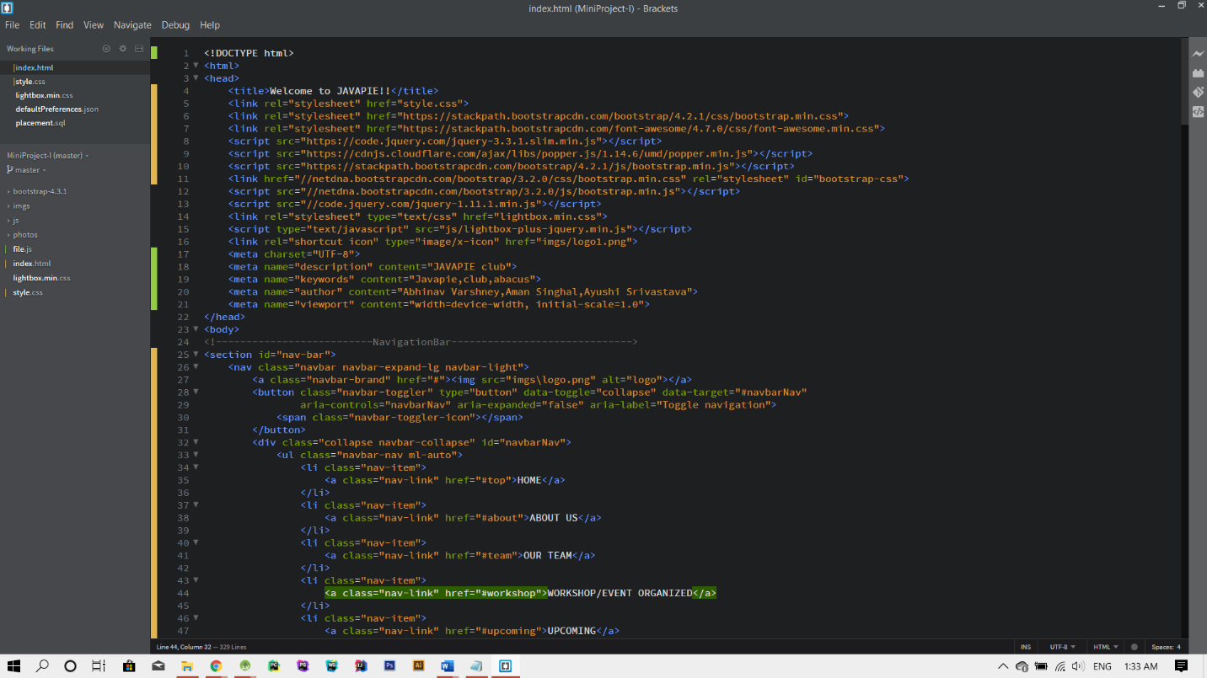

3.3 Web Browser

A web browser (commonly referred to as a browser) is a software application for accessing information on the World Wide Web. When a user requests a particular website, the web browser retrieves the necessary content from a web server and then displays the resulting web page on the user's device.

A web browser is not the same thing as a search engine, though the two are often confused.For a user, a search engine is just a website, such as Google Search, Bing, or DuckDuckGo, that stores searchable data about other websites. However, to connect to a website's server and display its web pages, a user must have a web browser installed.

Ex.Microsoft Edge,Google Chrome,Internet Explorer

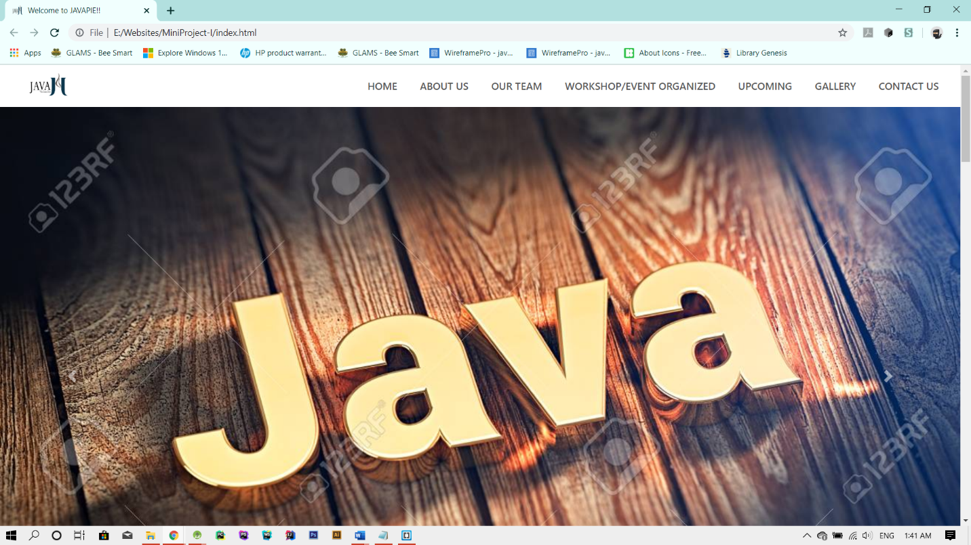

Web browser displaying the website

3.4 Technologies Used

Front-end is a term that involves the building of webpages and user interfaces for web-applications. It implements the structure, design, behavior, and animation of everything you see on the screen when you open up websites, web applications, or mobile apps. The core 3 technologies that all modern front-end web developers work to master are HTML5, CSS, and JavaScript.

3.4.1 HTML5

HTML5 is a software solution stack that defines the properties and behaviors of web page content by implementing a markup based pattern to it. HTML5 is the fifth and current major version of HTML, and subsumes XHTML. The current standard, the HTML Living Standard is developed by WHATWG, which is made up of the major browser vendors (Apple, Google, Mozilla, and Microsoft), with the Living Standard also existing in an abridged version. HTML5 was first released in public-facing form on 22 January 2008,with a major update and “W3C Recommendation” status in October 2014.

3.4.2 CSS

Cascading Style Sheets (CSS) is a style sheet language used for describing the presentation of a document written in a markup language like HTML. CSS is a cornerstone technology of the World Wide Web, alongside HTML and JavaScript.CSS is designed to enable the separation of presentation and content, including layout, colors, and fonts. This separation can improve content accessibility, provide more flexibility and control in the specification of presentation characteristics, enable multiple web pages to share formatting by specifying the relevant CSS in a separate .css file, and reduce complexity and repetition in the structural content.

3.4.3 Javascript

JavaScript ,often abbreviated as JS, is a high-level, interpreted scripting language that conforms to the ECMAScript specification. JavaScript has curly-bracket syntax, dynamic typing, prototype-based object-orientation, and first-class functions.

Alongside HTML and CSS, JavaScript is one of the core technologies of the World Wide Web. JavaScript enables interactive web pages and is an essential part of web applications. The vast majority of websites use it, and major web browsers have a dedicated JavaScript engine to execute it.

3.4.4 jQuery

jQuery is a JavaScript library designed to simplify HTML DOM tree traversal and manipulation, as well as event handling, CSS animation, and Ajax. It is free, open-source software using the permissive MIT License. As of May 2019, jQuery is used by 73% of the 10 million most popular websites. Web analysis indicates that it is the most widely deployed JavaScript library by a large margin, having 3 to 4 times more usage than any other JavaScript library.

3.4.5 Bootstrap

Bootstrap is a free and open-source CSS framework directed at responsive, mobile-first front-end web development. It contains CSS- and (optionally) JavaScript-based design templates for typography, forms, buttons, navigation and other interface components.

**Chapter 04**

**Software Design**

3.1 Use Case Diagram

A use case diagram is usually simple. It does not show the detail of the use cases:

•It only summarizes some of the relationships between use cases, actors, and systems.

•It does not show the order in which steps are performed to achieve the goals of each use case.

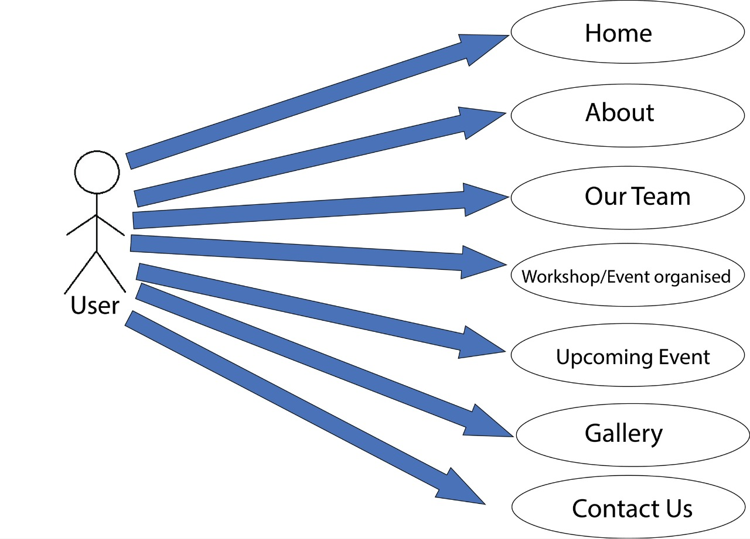

3.2 Data Flow Diagram

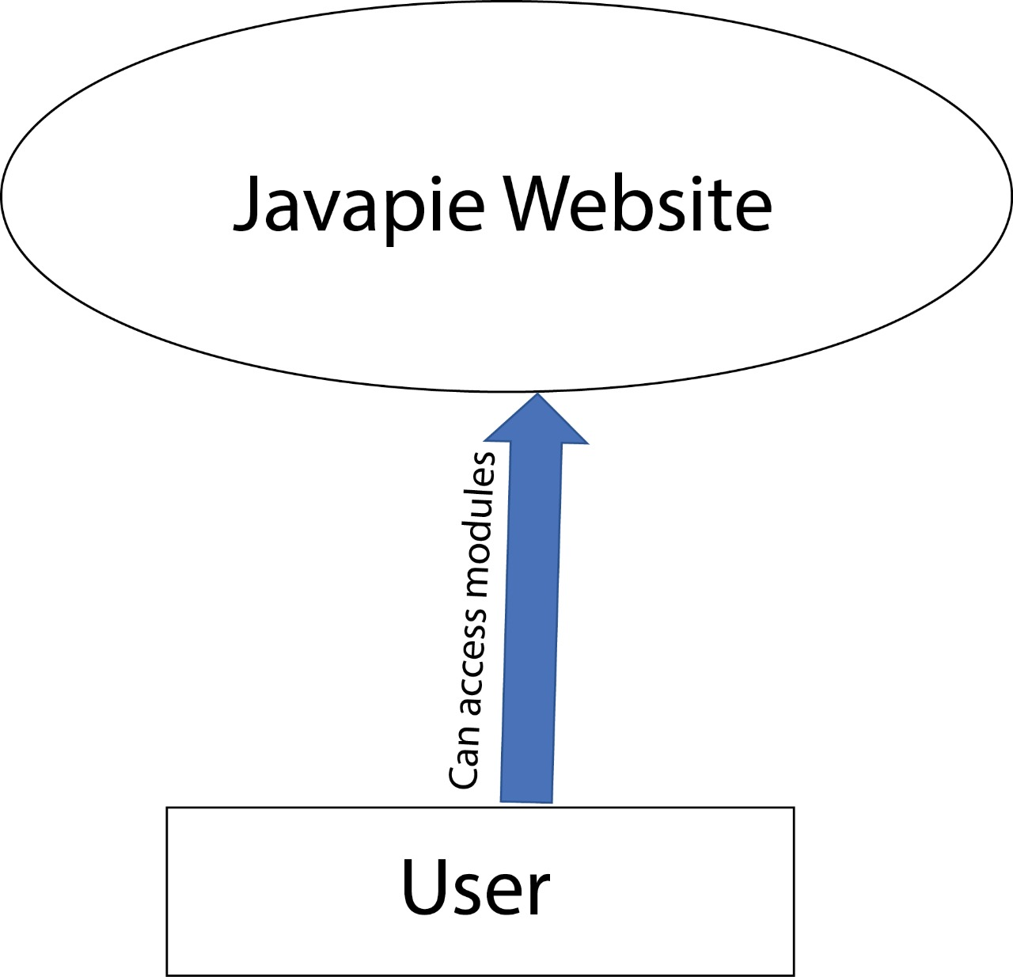

**Chapter 05**

**Implementation and User Interface**

5.1 Implementation details

We have used 5 frontend technologies to implement the project

1.HTML

2.CSS

3.Javascript

4.Bootstrap

5.jQuery

5.2 User Interface

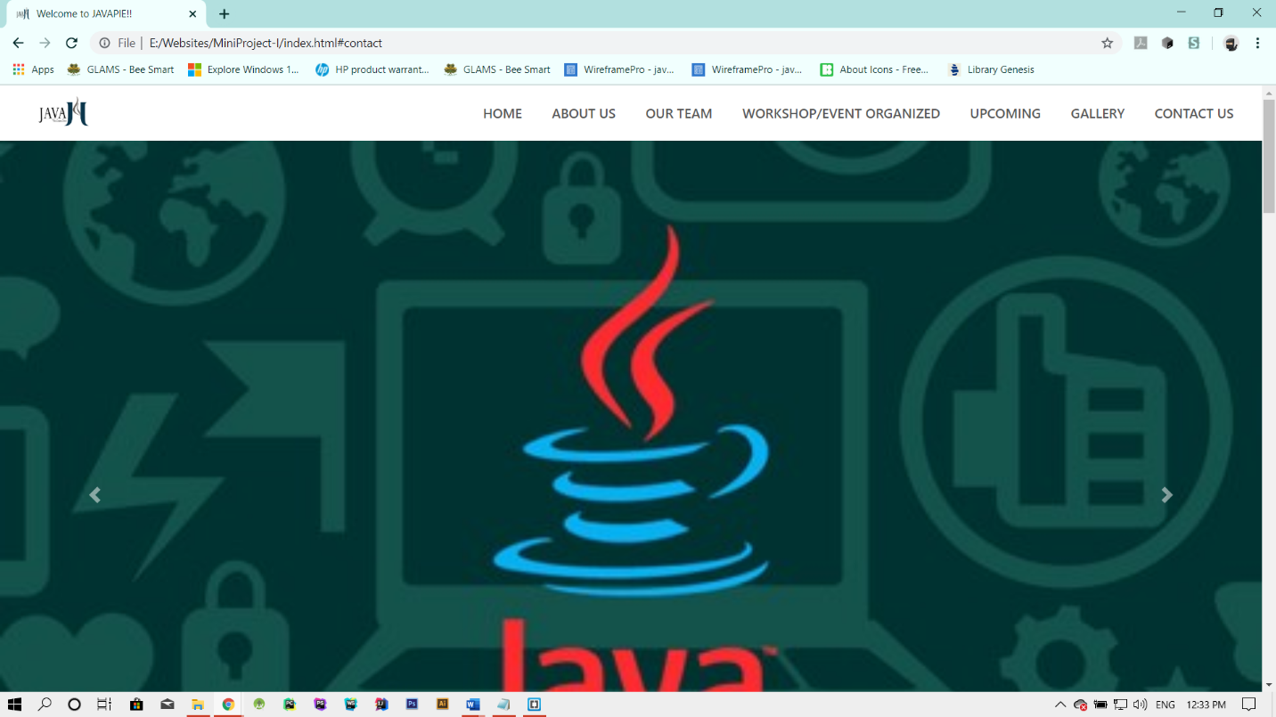

Home Page

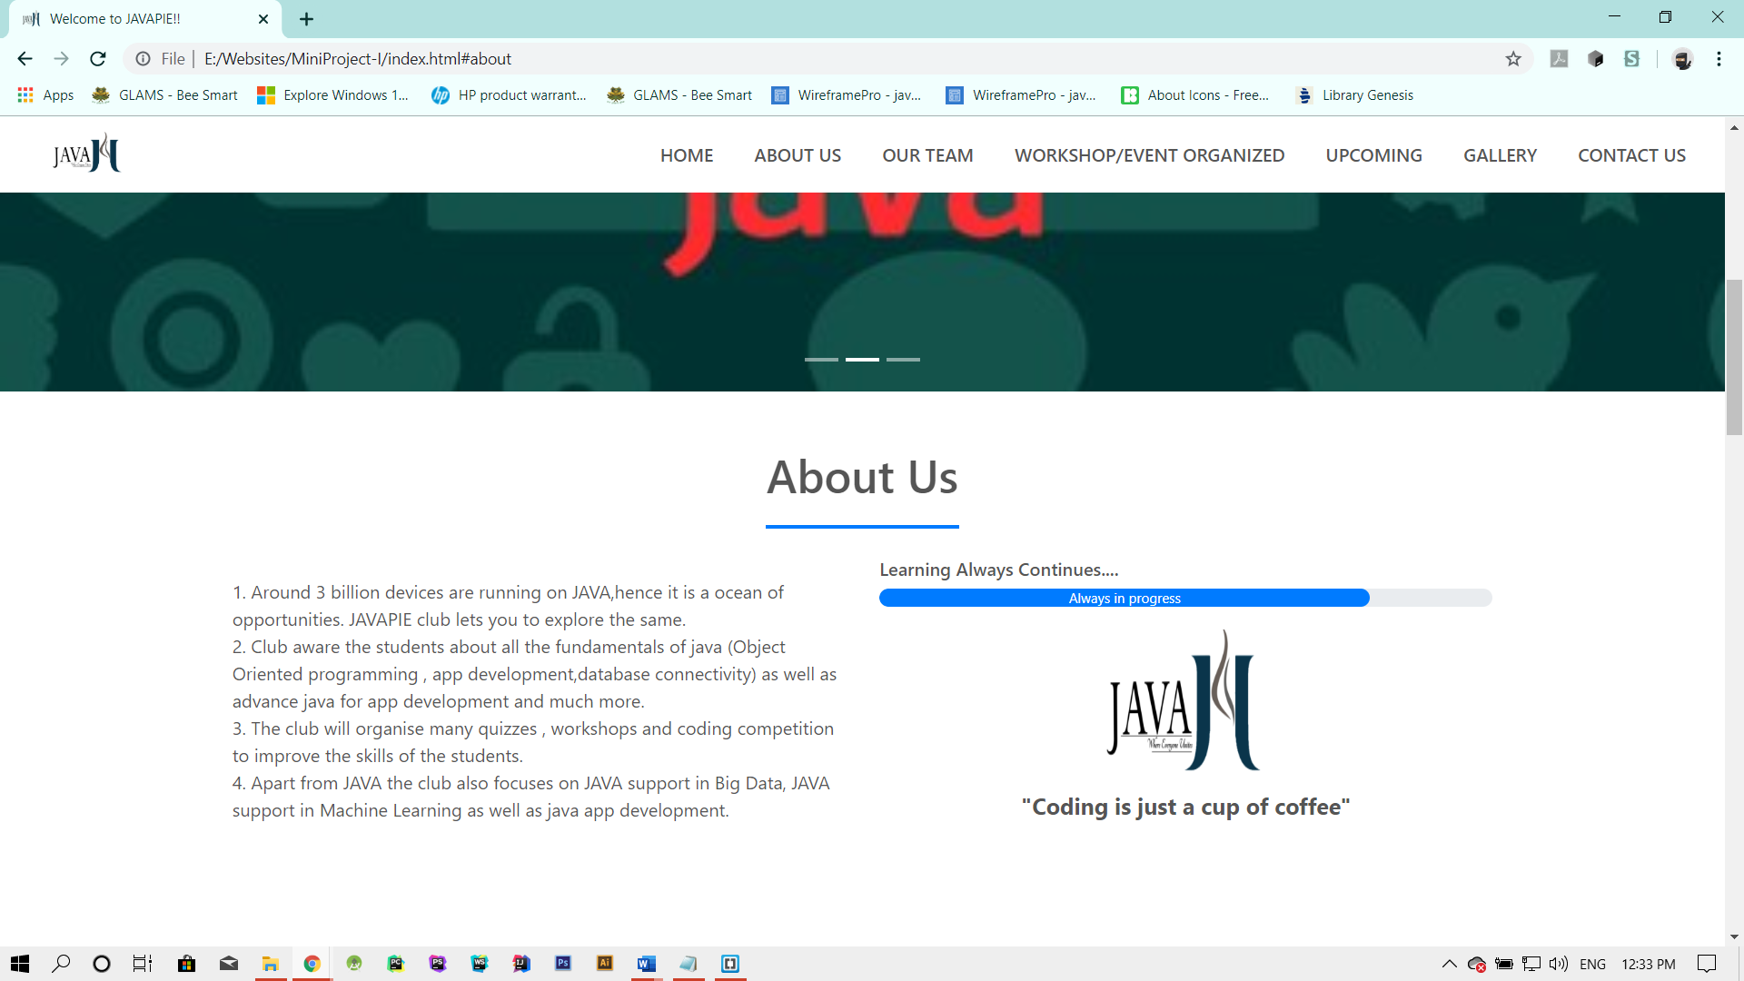

**About us section**

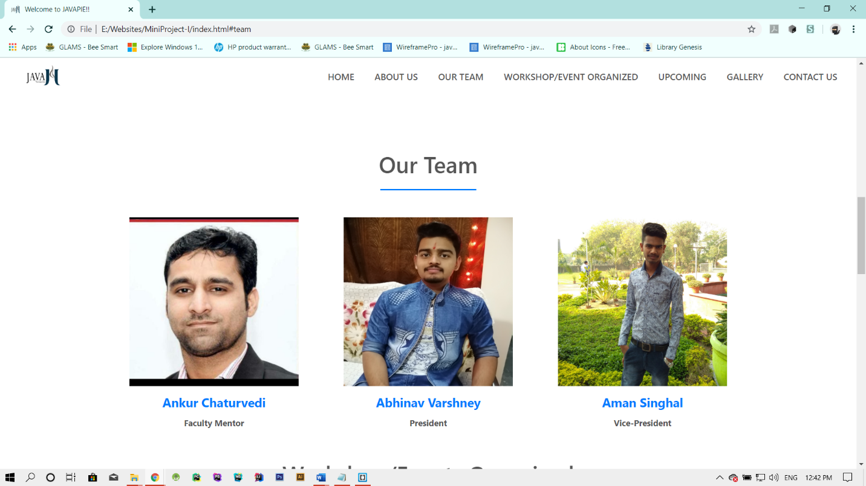

**Team Section**

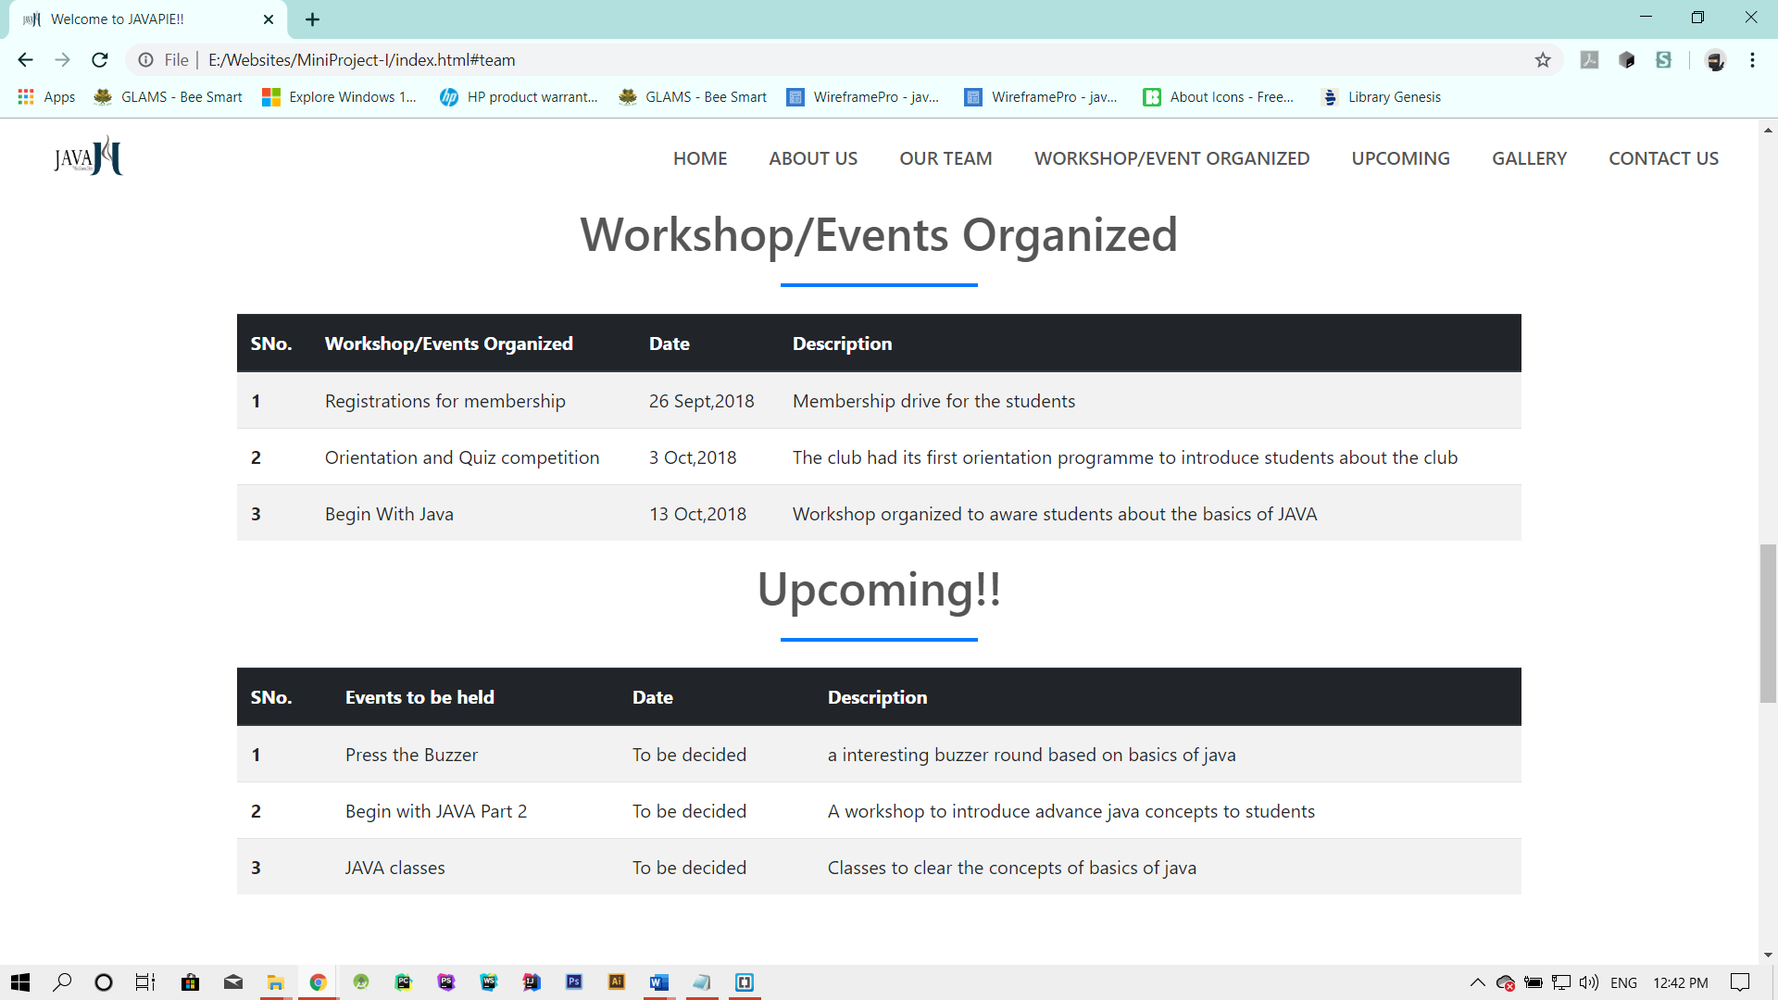

**Workshop/Events Organized and Upcoming**

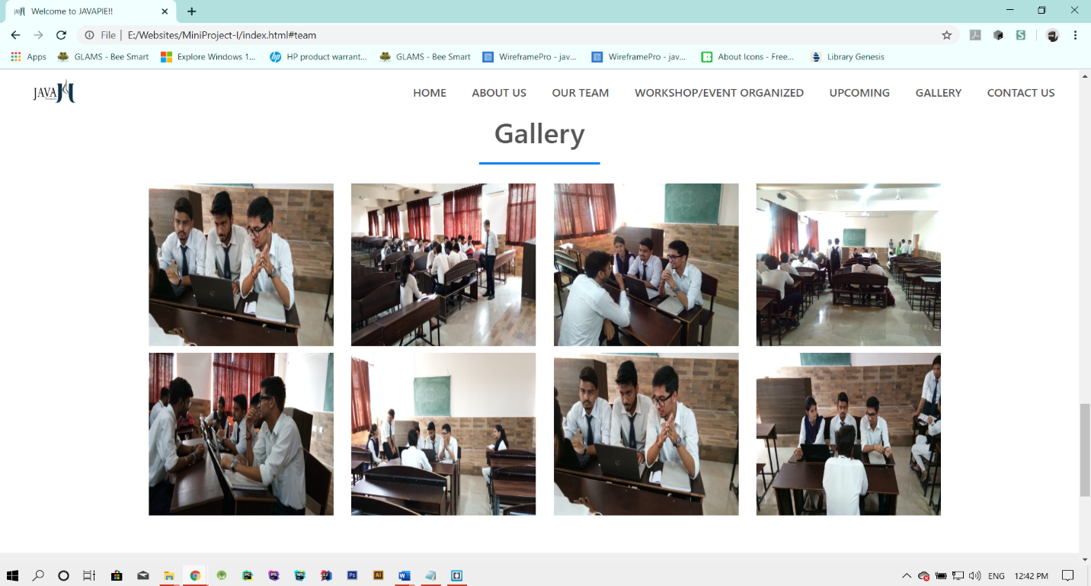

**Gallery section**

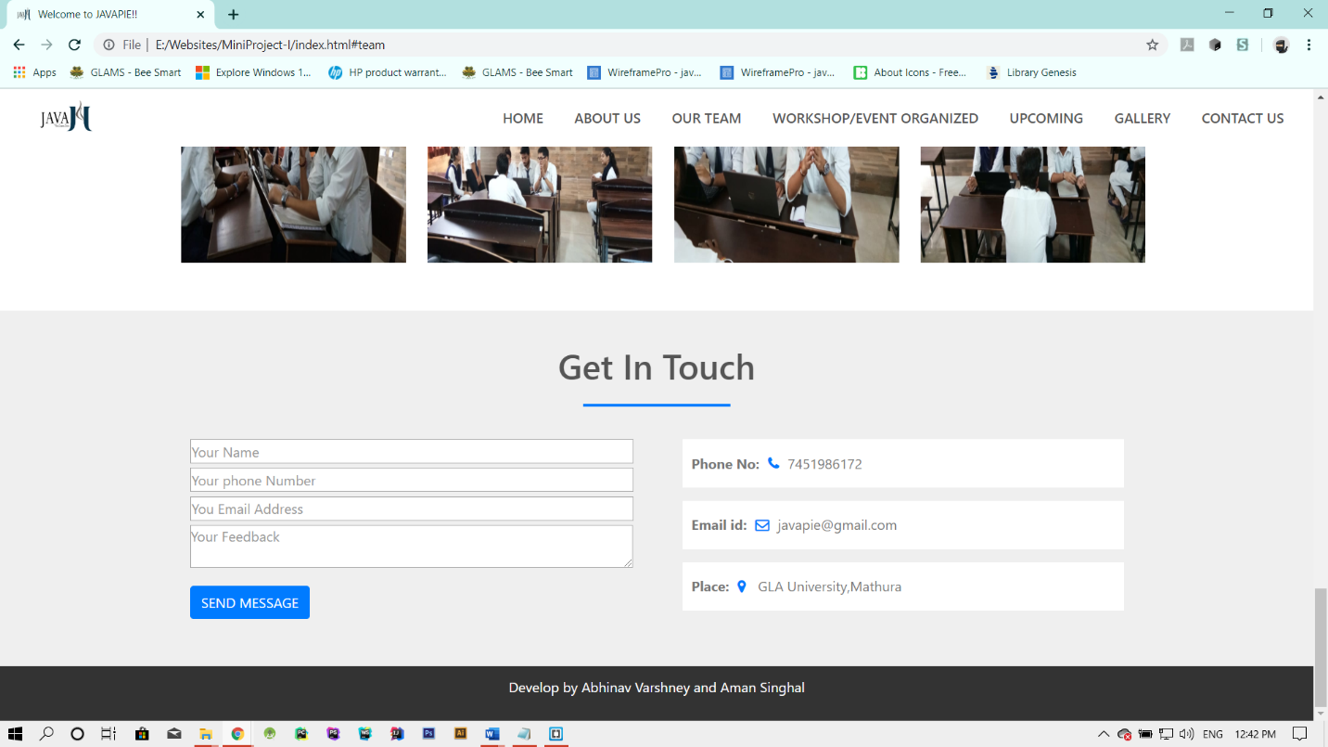

**About us section**

**References and Bibliography**

<https://www.w3schools.com/html/default.asp>

<https://www.w3schools.com/css/default.asp>

<https://www.w3schools.com/js/default.asp>

<https://www.w3schools.com/bootstrap4/default.asp>

<https://www.w3schools.com/jquery/default.asp>

[www.stackoverflow.com](http://www.stackoverflow.com)

[www.quora.com](http://www.quora.com/)

www.youtube.com

**Appendices**

**Code to link scripts,css files ,bootstrap**

<head>

<title>Welcome to JAVAPIE!!</title>

<link rel="stylesheet" href="style.css">

<link rel="stylesheet" href="https://stackpath.bootstrapcdn.com/bootstrap/4.2.1/css/bootstrap.min.css">

<link rel="stylesheet" href="https://stackpath.bootstrapcdn.com/font-awesome/4.7.0/css/font-awesome.min.css">

<script src="https://code.jquery.com/jquery-3.3.1.slim.min.js"></script>

<script src="https://cdnjs.cloudflare.com/ajax/libs/popper.js/1.14.6/umd/popper.min.js"></script>

<script src="https://stackpath.bootstrapcdn.com/bootstrap/4.2.1/js/bootstrap.min.js"></script>

<link href="//netdna.bootstrapcdn.com/bootstrap/3.2.0/css/bootstrap.min.css" rel="stylesheet" id="bootstrap-css">

<script src="//netdna.bootstrapcdn.com/bootstrap/3.2.0/js/bootstrap.min.js"></script>

<script src="//code.jquery.com/jquery-1.11.1.min.js"></script>

<link rel="stylesheet" type="text/css" href="lightbox.min.css">

<script type="text/javascript" src="js/lightbox-plus-jquery.min.js"></script>

<link rel="shortcut icon" type="image/x-icon" href="imgs/logo1.png">

<meta charset="UTF-8">

<meta name="description" content="JAVAPIE club">

<meta name="keywords" content="Javapie,club,abacus">

<meta name="author" content="Abhinav Varshney,Aman Singhal,Ayushi Srivastava">

<meta name="viewport" content="width=device-width, initial-scale=1.0">

</head>

**Code for navigation bar**

<section id="nav-bar">

<nav class="navbar navbar-expand-lg navbar-light">

<a class="navbar-brand" href="#"><img src="imgs\logo.png" alt="logo"></a>

<button class="navbar-toggler" type="button" data-toggle="collapse" data-target="#navbarNav"

aria-controls="navbarNav" aria-expanded="false" aria-label="Toggle navigation">

<span class="navbar-toggler-icon"></span>

</button>

<div class="collapse navbar-collapse" id="navbarNav">

<ul class="navbar-nav ml-auto">

<li class="nav-item">

<a class="nav-link" href="#top">HOME</a>

</li>

<li class="nav-item">

<a class="nav-link" href="#about">ABOUT US</a>

</li>

<li class="nav-item">

<a class="nav-link" href="#team">OUR TEAM</a>

</li>

<li class="nav-item">

<a class="nav-link" href="#workshop">WORKSHOP/EVENT ORGANIZED</a>

</li>

<li class="nav-item">

<a class="nav-link" href="#upcoming">UPCOMING</a>

</li>

<li class="nav-item">

<a class="nav-link" href="#gallery">GALLERY</a>

</li>

<li class="nav-item">

<a class="nav-link" href="#contact">CONTACT US</a>

</li>

</ul>

</div>

</nav>

</section>

**Code for Slider**

<div id="slider">

<div id="headerSlider" class="carousel slide" data-ride="carousel">

<ol class="carousel-indicators">

<li data-target="#headerSlider" data-slide-to="0" class="active"></li>

<li data-target="#headerSlider" data-slide-to="1"></li>

<li data-target="#headerSlider" data-slide-to="2"></li>

</ol>

<div class="carousel-inner">

<div class="carousel-item active">

<img class="d-block w-100" src="imgs\img2.jpg">

<div class="carousel-caption">

</div>

</div>

<div class="carousel-item">

<img class="d-block w-100" src="imgs\img4.jpg">

<div class="carousel-caption">

</div>

</div>

<div class="carousel-item">

<img class="d-block w-100" src="imgs\img5.jpg">

<div class="carousel-caption">

</div>

</div>

</div>

<a class="carousel-control-prev" href="#headerSlider" role="button" data-slide="prev">

<span class="carousel-control-prev-icon" aria-hidden="true"></span>

<span class="sr-only">Previous</span>

</a>

<a class="carousel-control-next" href="#headerSlider" role="button" data-slide="next">

<span class="carousel-control-next-icon" aria-hidden="true"></span>

<span class="sr-only">Next</span>

</a>

</div>

</div>

**Code for about section -display contents about the club**

<section id="about">

<div class="container">

<h1>About Us</h1>

<div class="row">

<div class="col-md-6">

<div class="about-content">

1. Around 3 billion devices are running on JAVA,hence it is a ocean of opportunities. JAVAPIE club

lets you to explore the same.<br>

2. Club aware the students about all the fundamentals of java (Object Oriented programming , app

development,database connectivity) as well as advance java for app development and much more.<br>

3. The club will organise many quizzes , workshops and coding competition to improve the skills of

the students.<br>

4. Apart from JAVA the club also focuses on JAVA support in Big Data, JAVA support in Machine

Learning as well as java app development.

</div>

</div>

<div class="col-md-6 skills-bar">

<p>Learning Always Continues....</p>

<div class="progress">

<div class="progress-bar" style="width:80%;">Always in progress</div>

</div>

<div align="center"><img style="width: 140px;height: 140px;align-self: center" src="imgs/logo1.png">

<br><q>Coding is just a cup of coffee</q></div>

</div>

</div>

</div>

</section>

**Code for Team members-section to display the team information**

<section id="team">

<div class="container">

<h1>Our Team</h1>

<div class="row">

<div class="col-md-4 profile-pic text-center">

<div class="img-box">

<img src="imgs\FM.jpg" class="img-responsive">

</div>

<h2>Ankur Chaturvedi</h2>

<h3>Faculty Mentor</h3>

</div>

<div class="col-md-4 profile-pic text-center">

<div class="img-box">

<img src="imgs\VP1.jpg" class="img-responsive">

<ul>

<a href="https://www.facebook.com/abhinav.varshney.946">

<li><i class="fa fa-facebook"></i></li>

</a>

<a href="https://www.linkedin.com/in/abhinav-varshney-b25089151">

<li><i class="fa fa-linkedin"></i></li>

</a>

<a href="https://www.gmail.com/abhinav.varshney_cs17@gla.ac.in">

<li><i class="fa fa-envelope-o"></i></li>

</a>

</ul>

</div>

<h2>Abhinav Varshney</h2>

<h3>President</h3>

</div>

<div class="col-md-4 profile-pic text-center">

<div class="img-box">

<img src="imgs\CDD.jpg" class="img-responsive">

<ul>

<a href="https://www.facebook.com/abhinav.varshney.946">

<li><i class="fa fa-facebook"></i></li>

</a>

<a href="https://www.linkedin.com/in/abhinav-varshney-b25089151">

<li><i class="fa fa-linkedin"></i></li>

</a>

<a href="https://www.gmail.com/abhinav.varshney_cs17@gla.ac.in">

<li><i class="fa fa-envelope-o"></i></li>

</a>

</ul>

</div>

<h2>Aman Singhal</h2>

<h3>Vice-President</h3>

</div>

</div>

</div>

</section>

**Code for gallery**

<section id="gallery">

<div class="container">

<h1>Gallery</h1>

<div class="row">

<div class="col-md-3 images-pic">

<a href="photos\img1.jpg" data-lightbox="mygallery" data-title="Interview session for membership"><img

src="photos\img1.jpg"></a></div>

<div class="col-md-3 images-pic">

<a href="photos\img2.jpg" data-lightbox="mygallery" data-title="Interview session for membership"><img

src="photos\img2.jpg"></a></div>

<div class="col-md-3 images-pic">

<a href="photos\img3.jpg" data-lightbox="mygallery" data-title="Interview session for membership"><img

src="photos\img3.jpg"></a></div>

<div class="col-md-3 images-pic">

<a href="photos\img4.jpg" data-lightbox="mygallery" data-title="Interview session for membership"><img

src="photos\img4.jpg"></a></div>

</div>

</div>

</section>

**Code for contact us -contact information**

<section id="contact">

<div class="container">

<h1>Get In Touch</h1>

<div class="row">

<div class="col-md-6">

<form class="contact-form">

<div class="from-group" style="margin-bottom: 5px;">

<input type="text" size="66.67%" name="form-control" placeholder="Your Name">

</div>

<div class="from-group" style="margin-bottom: 5px;">

<input type="tel" size="66.67%" name="from-control" placeholder="Your phone Number">

</div>

<div class="from-group" style="margin-bottom: 5px;">

<input type="email" size="66.67%" name="form-control" placeholder="You Email Address">

</div>

<div class="from-group" style="margin-bottom: 5px;">

<textarea name="from-control" placeholder="Your Feedback" rows="2" cols="69"></textarea>

</div>

<button type="submit" class="btn btn-primary">SEND MESSAGE</button>

</form>

</div>

<div class="col-md-6 contact-info">

<div class="follow"><b>Phone No:</b><i class="fa fa-phone"></i>7451986172</div>

<div class="follow"><b>Email id:</b><i class="fa fa-envelope-o"></i>javapie@gmail.com</div>

<div class="follow"><b>Place:</b><i class="fa fa-map-marker"></i>

GLA University,Mathura

</div>

</div>

</div>

</div>

</section>